Course Overview
The course is designed for beginners and focuses on the foundations of supervised learning over approximately 3 weeks (with an estimated 33 hours of content).
- Week 1: Introduction to Machine Learning & Linear Regression
  - Covers the difference between supervised and unsupervised learning.
  - Introduces the Linear Regression model, cost functions, and gradient descent.
- Week 2: Multiple Linear Regression
  - Extends linear regression to handle multiple input features.
  - Teaches optimization techniques like vectorization, feature scaling, and feature engineering.
- Week 3: Classification
  - Focuses on Logistic Regression for binary classification tasks (e.g., predicting categories).
  - Addresses overfitting and introduces regularization to improve model generalization.

WEEK 1:
Explanation of the algorithm in a Medium Article (check the same folder for pdf version, written by Jason Pradhananga):
https://medium.com/@jaysonyt2/andrew-ngs-supervised-learning-week-1-linear-regression-implementation-405b345ee08b

My Questions:
REGRESSION (trying to predict a numerical value):
- Why is the linear regression model using the formula y=wx+b instead of y=x? For a better fit. W is called the weight and b is called bias. See the pictures below.

- Linear regression could be univariate (one independent / input variable / feature) OR it could be multivariate (two or more independent / input variable / feature). First formula looks like y=wx+b, the 2nd one looks like Y=W1X1 + W2X2+….+b. The 2nd one will be 3D, or more plot not 2D.

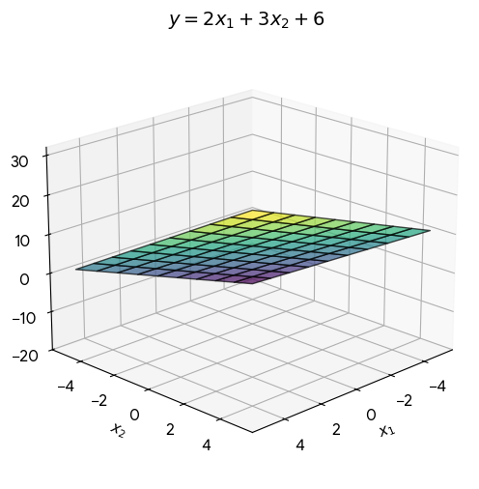
- In addition, both 1st and the 2nd one can have squared or cubed etc. powers to the input variables (X1, X2, ….) to better fit the data which will make the line or plane curved.
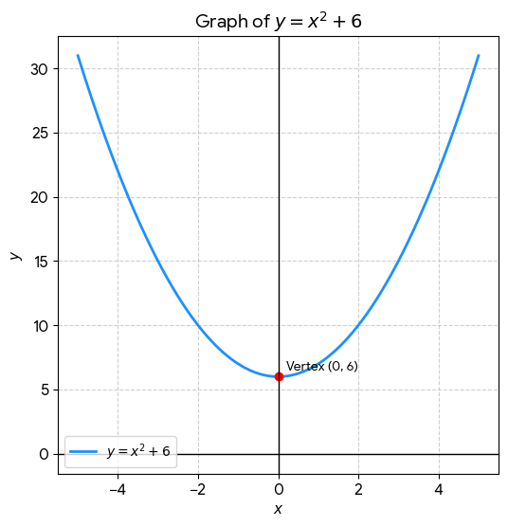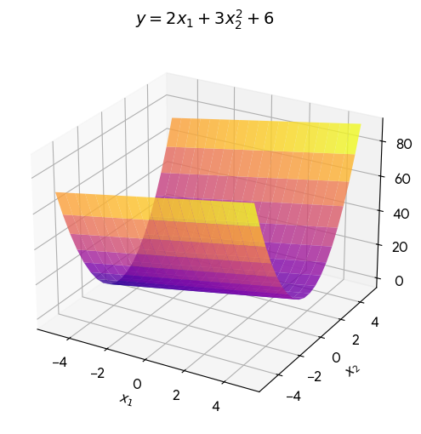

- Why do we need cost function (one implementation of cost function is mean squared error)? For better fit. We need to minimize the error.
- What is Gradient Descent doing? GD is used to come up with an optimal w and b which will give the lowest error or cost. This is done iteratively using different sets of w and b and calculating cost. If the cost is getting lower, then you know you are getting better fit and your GD algorithm is working.
- How does all this fit in the sickit learn fit and predict functions that we usually use to implement regression problems?

Key points to learn and understand in week 1 and week 2:

Core Objectives: Week 1 vs. Week 2
- Week 1 focuses on the foundational mechanics of a Single Variable (Univariate) Model.
- Week 2 scales those exact mechanics up to handle Multiple Features (Multivariate Data) efficiently.

1. Key Points to Learn in Week 1
Core Definitions
- Supervised Learning: Training models using labeled data where the correct answers (y) are provided.
- Regression: A type of supervised learning focused on predicting a continuous numerical value.
The Model & Cost Function
- The Linear Equation: Linear regression models data using the formula f_{w,b}(x) = wx + b.
- Parameters (w, b): Weights (w) control the line's slope, and the bias (b) controls the y-intercept.
- Squared Error Cost Function: Standard metric used to measure model accuracy, calculated as:
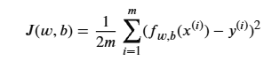
Optimization Mechanics
- Gradient Descent: Optimization algorithm that iteratively tweaks parameters to minimize total cost.
- The Derivative Term: Calculus slope calculation indicating which direction to adjust parameters.
- Learning Rate (α): Hyperparameter governing the size of steps taken down the cost curve.
- Simultaneous Updates: Rule dictating that w and b must be updated using their old values within the same iteration step.

2. Key Points to Learn in Week 2
Scaling the Math
- Multivariate Vector Notation: Grouping multiple features into vector and weights into vector to yield:
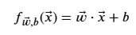
- Vectorization Utility: Eliminating slow code loops by processing dataset operations via parallel matrix math.

Optimization Enhancements
- Feature Scaling Importance: Normalizing wildly different data ranges so gradient descent does not distort or stall.
- Z-score Normalization: Formula converting features to a standard scale with a mean of 0 and standard deviation of 1.
- Learning Rate Diagnostics: Plotting cost versus iterations to verify if α is safely converging.
- Feature Engineering: Creating highly predictive inputs by mathematically combining existing features.
- Polynomial Regression: Fitting non-linear curves to data by elevating standard linear features to powers like x² or x³.

Can you explain like vectorization, feature scaling, and feature engineering from week 2?

Here is a breakdown of these three critical Week 2 concepts, explained through practical, real-world examples.

1. Vectorization: Ditching the "For Loop"
Vectorization is the practice of replacing slow, step-by-step code loops with fast, parallel matrix mathematics.
The Concept
Imagine you are a real estate agent calculating house prices. You have 10,000 houses, and for each house, you have 5 features (size, bedrooms, floors, age, zip code).
- Without Vectorization: Your computer behaves like a single clerk manually calculating the price for House 1, then moving to House 2, then House 3. In code, this requires a nested for loop. It is incredibly slow.
- With Vectorization: Your computer behaves like a factory floor with thousands of clerks working at the exact same split-second. It takes all 10,000 houses, multiplies them by their weights simultaneously, and spits out all 10,000 prices instantly.
In Python (NumPy)
# Unvectorized (Slow)
prediction = 0.0
for j in range(len(w)):
prediction += w[j] * x[j]
prediction += b

# Vectorized (Blazing Fast)
prediction = np.dot(w, x) + b
Why it matters: Modern computer hardware (CPUs and GPUs) has built-in parallel processing commands. NumPy uses these commands to run calculations at the hardware level, making your models train up to 100x faster.

2. Feature Scaling: Leveling the Playing Field
Feature scaling is the process of altering the ranges of your input features so they all span roughly the same scale (usually between -1 and 1).
The Problem
Imagine you are predicting house prices using two features:
- Size in square feet (x1): Ranges from 500 to 5,000.
- Number of bedrooms (x2): Ranges from 1 to 5.
Because the numbers for size are massive compared to bedrooms, a tiny change in the size weight (w1) causes wild swings in the final price prediction. If you map out the cost function, it looks like an incredibly long, narrow, oval valley.
When you run Gradient Descent, the math gets confused by the steepness of the size axis and the flatness of the bedroom axis. The algorithm will bounce back and forth wildly across the narrow valley walls, taking a massive amount of time to finally reach the bottom.
The Solution (Z-Score Normalization)
You scale the data so that every feature has a mean (µ) of 0 and a standard deviation (σ) of 1.
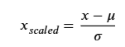

Why it matters: Once scaled, both features look similar to the model (e.g., ranging from roughly -2 to +2). The narrow oval valley transforms into a perfectly round bowl. Gradient Descent can now march in a straight line directly to the center, dramatically speeding up training.

3. Feature Engineering: Creating New Insights
Feature engineering is the process of using your human intuition to combine or transform raw features into completely new ones that make it easier for a linear model to make accurate predictions.
The Concept
A standard linear model cannot understand complex relationships on its own. It only looks at individual features independently. Feature engineering allows you to feed the model the "missing links."
Examples
- Combining Features: Imagine you are buying a plot of land and have two raw features: frontage_width and depth. A linear model will struggle to figure out how they interact. By multiplying them together, you engineer a brand-new feature: total_area = width * depth. A single area feature is infinitely more predictive of land price than width and depth on their own.
- Polynomial Features: Imagine a car's fuel efficiency based on speed. At low speeds, efficiency is bad. At medium speeds (highway), it is great. At extremely high speeds, wind resistance makes it bad again. A straight line cannot capture this. By squaring the speed feature, you engineer a curve. This allows your linear model to bend and fit the upside-down "U" shape of the data perfectly.
Why it matters: It proves that you do not always need a hyper-complex deep learning model to solve a problem. Often, a simple linear model paired with clever, human-engineered features will yield incredible results.

Would you like to dive into a specific feature engineering project idea?

FEATURE ENGINEERING:

Let’s dive into a comprehensive feature engineering project idea: Predicting Ride-Hailing Trip Fares and Durations (similar to building a model for Uber or Lyft).
This is a classic machine learning problem where raw data—like timestamps and GPS coordinates—is practically useless to a linear model without creative feature engineering.

The Raw Dataset
Imagine your initial dataset only contains five basic columns:
- pickup_datetime (e.g., 2026-05-23 17:30:00)
- pickup_latitude & pickup_longitude
- dropoff_latitude & dropoff_longitude
- passenger_count
- fare_amount (Target variable $y$)
If you feed these raw numbers straight into a linear regression model, it will perform terribly. A linear model cannot naturally understand that a specific latitude coordinate means "the airport," or that 5:00 PM means "rush hour."
Here is how we use feature engineering to unlock the predictive power of this data.

1. Temporal Engineering (Extracting Time Insights)
A single timestamp string (2026-05-23 17:30:00) is just text to a computer. We need to break it down into cyclical and categorical features.
- is_rush_hour (Binary): Create a 1 or 0 flag. If the hour is between 7–9 AM or 4–7 PM on a weekday, set it to 1. This helps the model capture traffic delays.
- day_of_week & is_weekend: Traffic and social patterns change drastically on Saturdays versus Tuesdays.
- Cyclical Time Encoding: Hours repeat. 11:00 PM (23:00) is physically close to 1:00 AM (01:00), but numerically 23 and 1 are far apart. We can engineer two features using trigonometry:
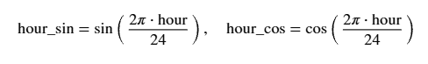

2. Geospatial Engineering (Distance & Locations)
Raw GPS coordinates do not tell a linear model how far apart two points are.
- Manhattan Distance: In a city, cars cannot fly directly over buildings. They must drive in a grid. We engineer a "Manhattan Distance" feature by calculating the absolute differences in latitude and longitude to mimic city blocks.
- Haversine (Great-Circle) Distance: For long distances, we apply the Haversine formula to find the literal "as-the-crow-flies" distance in miles or kilometers using spherical geometry.
- Airport Proximity (Distance to Hubs): Trips to and from major airports usually have flat rates, tolls, or high demand. You can hardcode the coordinates of the city's major airport and engineer a feature: distance_to_airport = absolute_difference(pickup, airport). If this value is close to 0, the model instantly associates it with airport pricing structures.

3. Interaction & Polynomial Features (Combining Variables)
Andrew Ng emphasizes combining variables to let simple models capture complex relationships.
- passenger_per_mile: Divide passenger_count by your engineered haversine_distance. A high number of passengers over a incredibly short distance might represent a specific type of ride behavior (like a group sharing a short shuttle).
- Distance Squared (x²): Fuel consumption and driver fatigue do not always scale perfectly linearly over massive distances. Squaring the distance feature allows the model's price prediction curve to bend smoothly for exceptionally long trips.

Python/Pandas Implementation Example
Here is how you would write the code for some of these engineered features:
import pandas as pd
import numpy as np

def engineer_taxi_features(df):
# Ensure datetime format
df['pickup_datetime'] = pd.to_datetime(df['pickup_datetime'])

# 1. Temporal Features
df['hour'] = df['pickup_datetime'].dt.hour
df['day_of_week'] = df['pickup_datetime'].dt.dayofweek
df['is_weekend'] = df['day_of_week'].isin([5, 6]).astype(int)
df['is_rush_hour'] = df['hour'].isin([7, 8, 9, 16, 17, 18]).astype(int)

# 2. Geospatial Features (Manhattan Distance Approximation)
lat_dist = np.abs(df['pickup_latitude'] - df['dropoff_latitude'])
lon_dist = np.abs(df['pickup_longitude'] - df['dropoff_longitude'])
# Convert rough degrees to miles/km (approx. 69 miles per degree)
df['manhattan_distance_miles'] = (lat_dist + lon_dist) * 69.0

# 3. Interaction Feature
# Add a small epsilon (1e-5) to prevent dividing by zero
df['lat_lon_ratio'] = lat_dist / (lon_dist + 1e-5)

return df

What to Watch Out For
- Feature Leakage: Never engineer a feature using information from the future or from the target variable itself. For example, including trip_duration_minutes to predict fare_amount might look great on paper, but in the real world, you do not know the exact duration until after the ride is already finished!
- The Need for Feature Scaling: Because your engineered manhattan_distance_miles might range from 0 to 50, while is_rush_hour is strictly 0 or 1, you must apply the Z-score normalization you learned in Week 2 right after creating these features.

Would you like to explore how we would handle categorical features (like different neighborhoods) using one-hot encoding, or should we move on to discussing how Week 3's logistic regression handles classification tasks?

One-hot encoding:

In Week 3, Andrew Ng introduces multi-class classification, which naturally leads to handling data that isn't numerical. One-Hot Encoding is the standard technique used to convert categorical data (like words, labels, or zip codes) into a binary format that a machine learning model can mathematically process.

1. The Problem: Why We Need It
Imagine your ride-hailing dataset has a categorical feature called Car_Type with three possibilities: Eco, Premium, and SUV.
A machine learning model cannot multiply a weight parameter (w) by the word "Premium". It only understands numbers.
The Naive Fix (Label Encoding)
You might try assigning each category a simple number:
- Eco = 1
- Premium = 2
- SUV = 3
Why this fails: A linear or logistic regression model will look at these numbers and assume an inherent order or mathematical scale. The math will interpret that an SUV (3) is worth exactly three times as much as an Eco (1), or that a Premium (2) is the exact mathematical average of an Eco and an SUV. This false relationship severely distorts the model's weights.

2. The Solution: One-Hot Encoding
Instead of keeping all categories in a single column, you explode that single column into multiple binary columns (one column for every unique category).
For any given row, only one column can be active ("hot"), receiving a value of 1. All other columns receive a 0.
Raw Car_Type | Car_Type_Eco | Car_Type_Premium | Car_Type_SUV
Eco | 1 | 0 | 0
Premium | 0 | 1 | 0
SUV | 0 | 0 | 1
Eco | 1 | 0 | 0
How the Model Interprets This
Now, the model assigns an independent weight ($w$) to each column:
If a customer orders an SUV, the equation completely cancels out the Eco and Premium terms by multiplying them by 0, leaving only the custom mathematical weight for an SUV.

3. Implementation in Python (Pandas)
In real-world workflows, doing this manually is tedious. Pandas provides a built-in function called pd.get_dummies() to handle this instantly.
import pandas as pd

# Sample dataframe
data = {'Trip_ID': [1, 2, 3],
'Car_Type': ['Eco', 'Premium', 'SUV']}
df = pd.DataFrame(data)

# Apply One-Hot Encoding
df_encoded = pd.get_dummies(df, columns=['Car_Type'], dtype=int)

print(df_encoded)
Output:
Trip_ID Car_Type_Eco Car_Type_Premium Car_Type_SUV
0 1 1 0 0
1 2 0 1 0
2 3 0 0 1

4. The "Dummy Variable Trap" (Advanced Note)
If you are using basic, unregularized linear regression, one-hot encoding can introduce a mathematical issue known as multicollinearity.
Look at the columns: if Car_Type_Eco is 0 and Car_Type_Premium is 0, the car must be an SUV. The third column is mathematically redundant because its state is perfectly predictable based on the first two.
- The Fix: In standard statistics, you often drop one category column (using pd.get_dummies(..., drop_first=True)).
- Andrew Ng's Context: If you are using Regularization (which you learn in Week 3), the L2 penalty gracefully handles this redundancy automatically, so dropping a column is not strictly required.

WEEK 3:

Andrew ng week 3 classification - how it addresses overfitting and regularization?
Week 3 of Andrew Ng’s Machine Learning Specialization on Coursera is entirely dedicated to Classification and Regularization using Logistic Regression. It transitions you from predicting continuous numbers (linear regression) to predicting distinct categories, like "Yes/No," "Spam/Not Spam," or "Malignant/Benign."

In Week 3 of Andrew Ng’s Machine Learning Specialization on Coursera, the curriculum introduces logistic regression for classification and explains how high-order polynomial features can lead to a highly complex, "wiggly" decision boundary. This concept directly bridges the conversation into overfitting (high variance) and how regularization solves it by penalizing excessive model complexity. [1, 2, 3, 4]

Here is how Week 3 breaks down these concepts:
1. Identifying the Problem of Overfitting
Andrew Ng categorizes model fitting into three states: [5]
- Underfitting (High Bias): The model is too simple. For example, using a straight line to separate data points that require a curved boundary. [5, 6, 7]
- Just Right: The decision boundary generalizes well to unseen data. [2, 5, 8]
- Overfitting (High Variance): The model fits the training data too perfectly. If you use too many features , the decision boundary contorts wildly to fit every single training instance. This causes the cost function to be nearly zero on the training set, but it fails to generalize to new data. [2, 6]
2. The Three Ways to Address Overfitting
According to the lecture, you have three primary levers to combat overfitting: [9, 10]
- Collect more training data: A larger dataset forces the algorithm to learn a simpler, more generalized function. [9]
- Feature selection: Manually choose which features to keep and eliminate the rest. The downside is that you might discard critical information. [9, 11]
- Regularization: Keep all the features, but reduce the magnitude (values) of the parameters . This is highly effective when you have many features that each contribute a tiny bit to the prediction. [9, 11]
3. How Regularization Works
Regularization forces the optimization algorithm to keep the weight parameters small. Small weights mean that high-order polynomial features have a muted impact, which smoothens out the wiggly decision boundary into a simpler curve. [3]
Modifying the Cost Function
To implement this, a penalty term (specifically, L2 regularization) is added to the end of the standard logistic regression cost function. [5, 12]
- 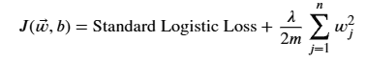’
- The Penalty: By adding 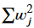 to the cost, gradient descent is forced to minimize not just the classification error, but also the size of the weights.
- The Intercept (b): By convention in Andrew Ng's course, the bias parameter b is left unregularized.
- The Regularization Parameter (lambda λ): This controls the trade-off between fitting the training data well and keeping the weights small. [3]
Tuning lambda λ (The Trade-off)
- If λ = 0: No regularization is applied. The model will overfit the data if there are too many features.
- If λ is extremely large (e.g., 10¹⁰) The weight parameters (w_{j}) are penalized so heavily they drop nearly to zero. The model simplifies to f(x) ≈ g(b), resulting in a flat decision boundary that underfits the data (high bias).
- An optimal λ: Balances both terms to achieve a smooth decision boundary that generalizes well. [3]
4. Impact on Gradient Descent Updates
When you run gradient descent on a regularized cost function, the update rule for the weights changes. In each iteration, the formula automatically shrinks the weight by a small fraction before subtracting the standard gradient. This continuous downward pressure prevents any single feature from overpowering the model, resulting in a cleaner, highly-stable classification boundary. [3, 13, 14]

[1] https://www.coursera.org
[2] https://www.youtube.com
[3] https://www.youtube.com
[4] https://medium.com
[5] https://github.com
[6] https://www.youtube.com
[7] https://apxml.com
[8] https://github.com
[9] https://www.youtube.com
[10] https://medium.com
[11] https://www.scribd.com
[12] https://medium.com
[13] https://www.youtube.com
[14] https://builtin.com

